# Proposal

This project is intended to mimic the following steps of a professional web development system:

* Deciding on a data set to address
* Deciding what your application will be communicating with that data
* Designing a back-end API that will translate data from an external source to your application
* Designing a front-end web application to communicate with your server and display your information using an attractive and interesting method of data visualization

## Required Proposal Sections

The proposal you present should have the following 4 things, outlined with the requirements below:

1. Problem Statement (50 pts)
2. Technology Decisions (30 pts)
3. Initial Wireframes (20 pts)

### **Problem (50 pts)**

I’m hoping to assist in finding deals/discounts for video games online. The people who would care about this would be gamers who want to save money and not have to deal with the new outrageous Triple-A game prices. My system will be a collection of discounted games which will tell users what games are discounted and by how much. I could also find a way to sort the games by popularity to find popular games that are now going on sale. I’ve chosen to work with CheapShark API because it provides exactly what I’m looking for, “Steam/PC Game Prices and Deals”. I will either go with just the Steam approach because of the popularity of Steam, or just go all in with all the stores that are available. For the Front End development I will provide an image/name (or both) for the title, rating, discount/price, and possibly other attributes. I want to make a filtering system and/or search box to return an exact game or games a user may be looking for.

### **Technology Decisions (30 pts)**

Your project will require you to make an API on both the backend and frontend, so it is important to break down what elements you will utilize. You will also be required to account for having a database, and some integration between these.

To develop the Front End I want to incorporate HTML, CSS, and Javascript. I am unfamiliar with frameworks but I would want a filtering feature to allow users to easily find their desired discounts. There should be simple inputs/interactables for the user to use to get the result he/she wants. I will want to store the user’s data somehow whether that is saving their inputs to match what the API says, or even maybe creating a save list or a “liked” list for users to keep track of their items.

### 

### **Initial Wireframes (20 pts)**

1. Home/Main Page

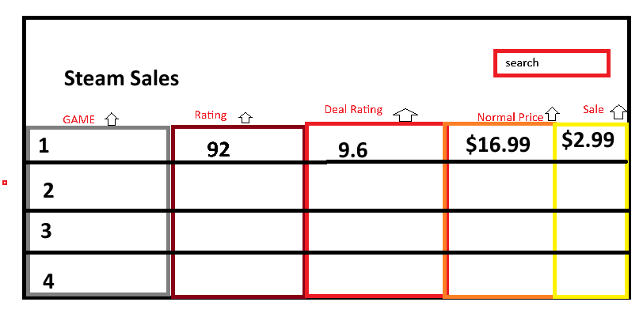

1. About Page (information)
   1. Welcome to Steam Sales! This is my INST377 project that tells users the best updates and deals on games that go on sale on Steam. Navigating through Steam you can look for a variety of games but it could get too broad and overwhelming. With my website you are able to view the top steam sales all in one place!
2. Help Page (information)
   1. How to navigate:
   2. Game - click the arrow to sort the game in alphabetical order
   3. Rating - click the arrow to sort the rating in ascending/descending order
   4. Deal Rating - click the arrow to sort the deal rating in ascending/descending order
   5. Normal Price - click the arrow to sort the normal price in ascending/descending order
   6. Sale - click the arrow to sort the sale in ascending/descending order